**Backend User Table:**

User table is to manage the user accounts for each employee.

The picture below is the view of the user table which is you can create, update and delete the item you will create. It shows the reference table 1.1

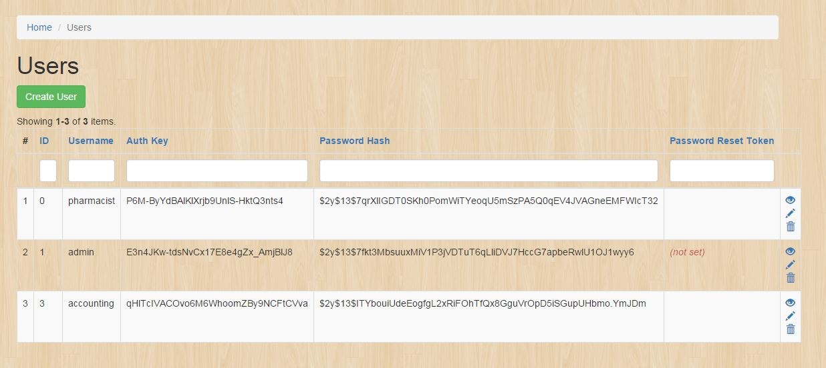

To create a Position just simply clicks this button:



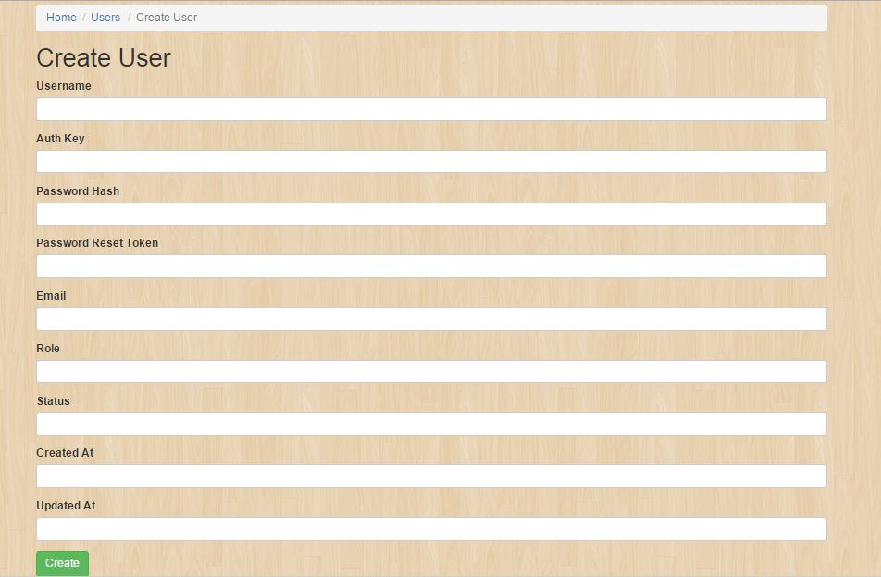It will display these fields: